Project 3 Proposal

GDog and the Coding Ninjas

1. Project title: Change Forecast
2. Project description: This application will be a mock-up for a proposed GE internal project. This application would store a subset of mock changes to then be reviewed and published as the dashboard to the GE community
3. User story:

AS A change executive

I WANT to see an application that provides a view of upcoming Major changes over a period of time that can be reviewed and then published in a dashboard format.

Access in this demonstration environment will require authentication through a local user database which allows users to create their own accounts.

Each change will have two “review states”, outside of the ServiceNow state. The “review states” are either Reviewed or Pending (defaulting to Pending).

Allow for searching of change numbers and descriptions.

Logout button to redirect the user to the sign in page

1. Wireframe or sketch of the design: <https://github.com/gehanstedt/recipe-mate/blob/main/Project%202%20Wirechart.png>
2. Database

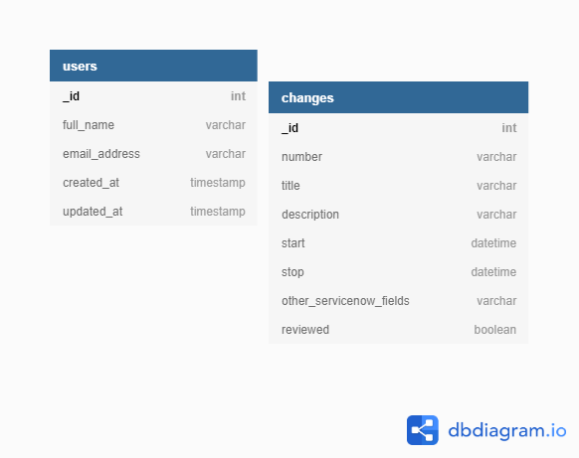

1. New technologies to be used:
   1. JWT
   2. Bcrypt
   3. React Bootstrap
   4. Moment
2. Rough breakdown of tasks
   1. Repo Owner- Greg Hanstedt
   2. Front end:
      * Dexter Burns
      * Denise Quarles
      * Jerron McGinnis
      * Sean Stephens
   3. Back end:
      * Greg Hanstedt
      * Donna Clever
      * Richard Matthews